### 

### Semester Two Examination, 2020

### Question/Answer booklet

# MATHEMATICS METHODS

**UNIT 1 AND 2**

## Section Two:

## Calculator-assumed

Name: SOLUTIONS

Teacher’s Name:_______________________________________________

Time allowed for this section

Reading time before commencing work: ten minutes

Working time: one hundred minutes

## Materials required/recommended for this section

***To be provided by the supervisor***

This Question/Answer booklet

Formula sheet (retained from Section One)

***To be provided by the candidate***

Standard items: pens (blue/black preferred), pencils (including coloured), sharpener, correction fluid/tape, eraser, ruler, highlighters

Special items: drawing instruments, templates, notes on two unfolded sheets of A4 paper, and up to three calculators approved for use in this examination

## Important note to candidates

No other items may be taken into the examination room. It is **your** responsibility to ensure that you do not have any unauthorised material. If you have any unauthorised material with you, hand it to the supervisor **before** reading any further.

| Question | Marks | Max | Question | Marks | Max |
| --- | --- | --- | --- | --- | --- |
| 10 |  | 4 | 18 |  | 9 |
| 11 |  | 10 | 19 |  | 8 |
| 12 |  | 4 | 20 |  | 4 |
| 13 |  | 3 | 21 |  | 4 |
| 14 |  | 5 | 22 |  | 8 |
| 15 |  | 4 | 23 |  | 6 |
| 16 |  | 4 |
| 17 |  | 12 |

**Structure of this paper**

| Section | Number of questions available | Number of questions to be answered | Working time (minutes) | Marks available | Percentage of examination |
| --- | --- | --- | --- | --- | --- |
| Section One:  Calculator-free | 9 | 9 | 50 | 44 | 34 |
| Section Two:  Calculator-assumed | 14 | 14 | 100 | 85 | 66 |
|  |  |  |  | **Total** | 100 |

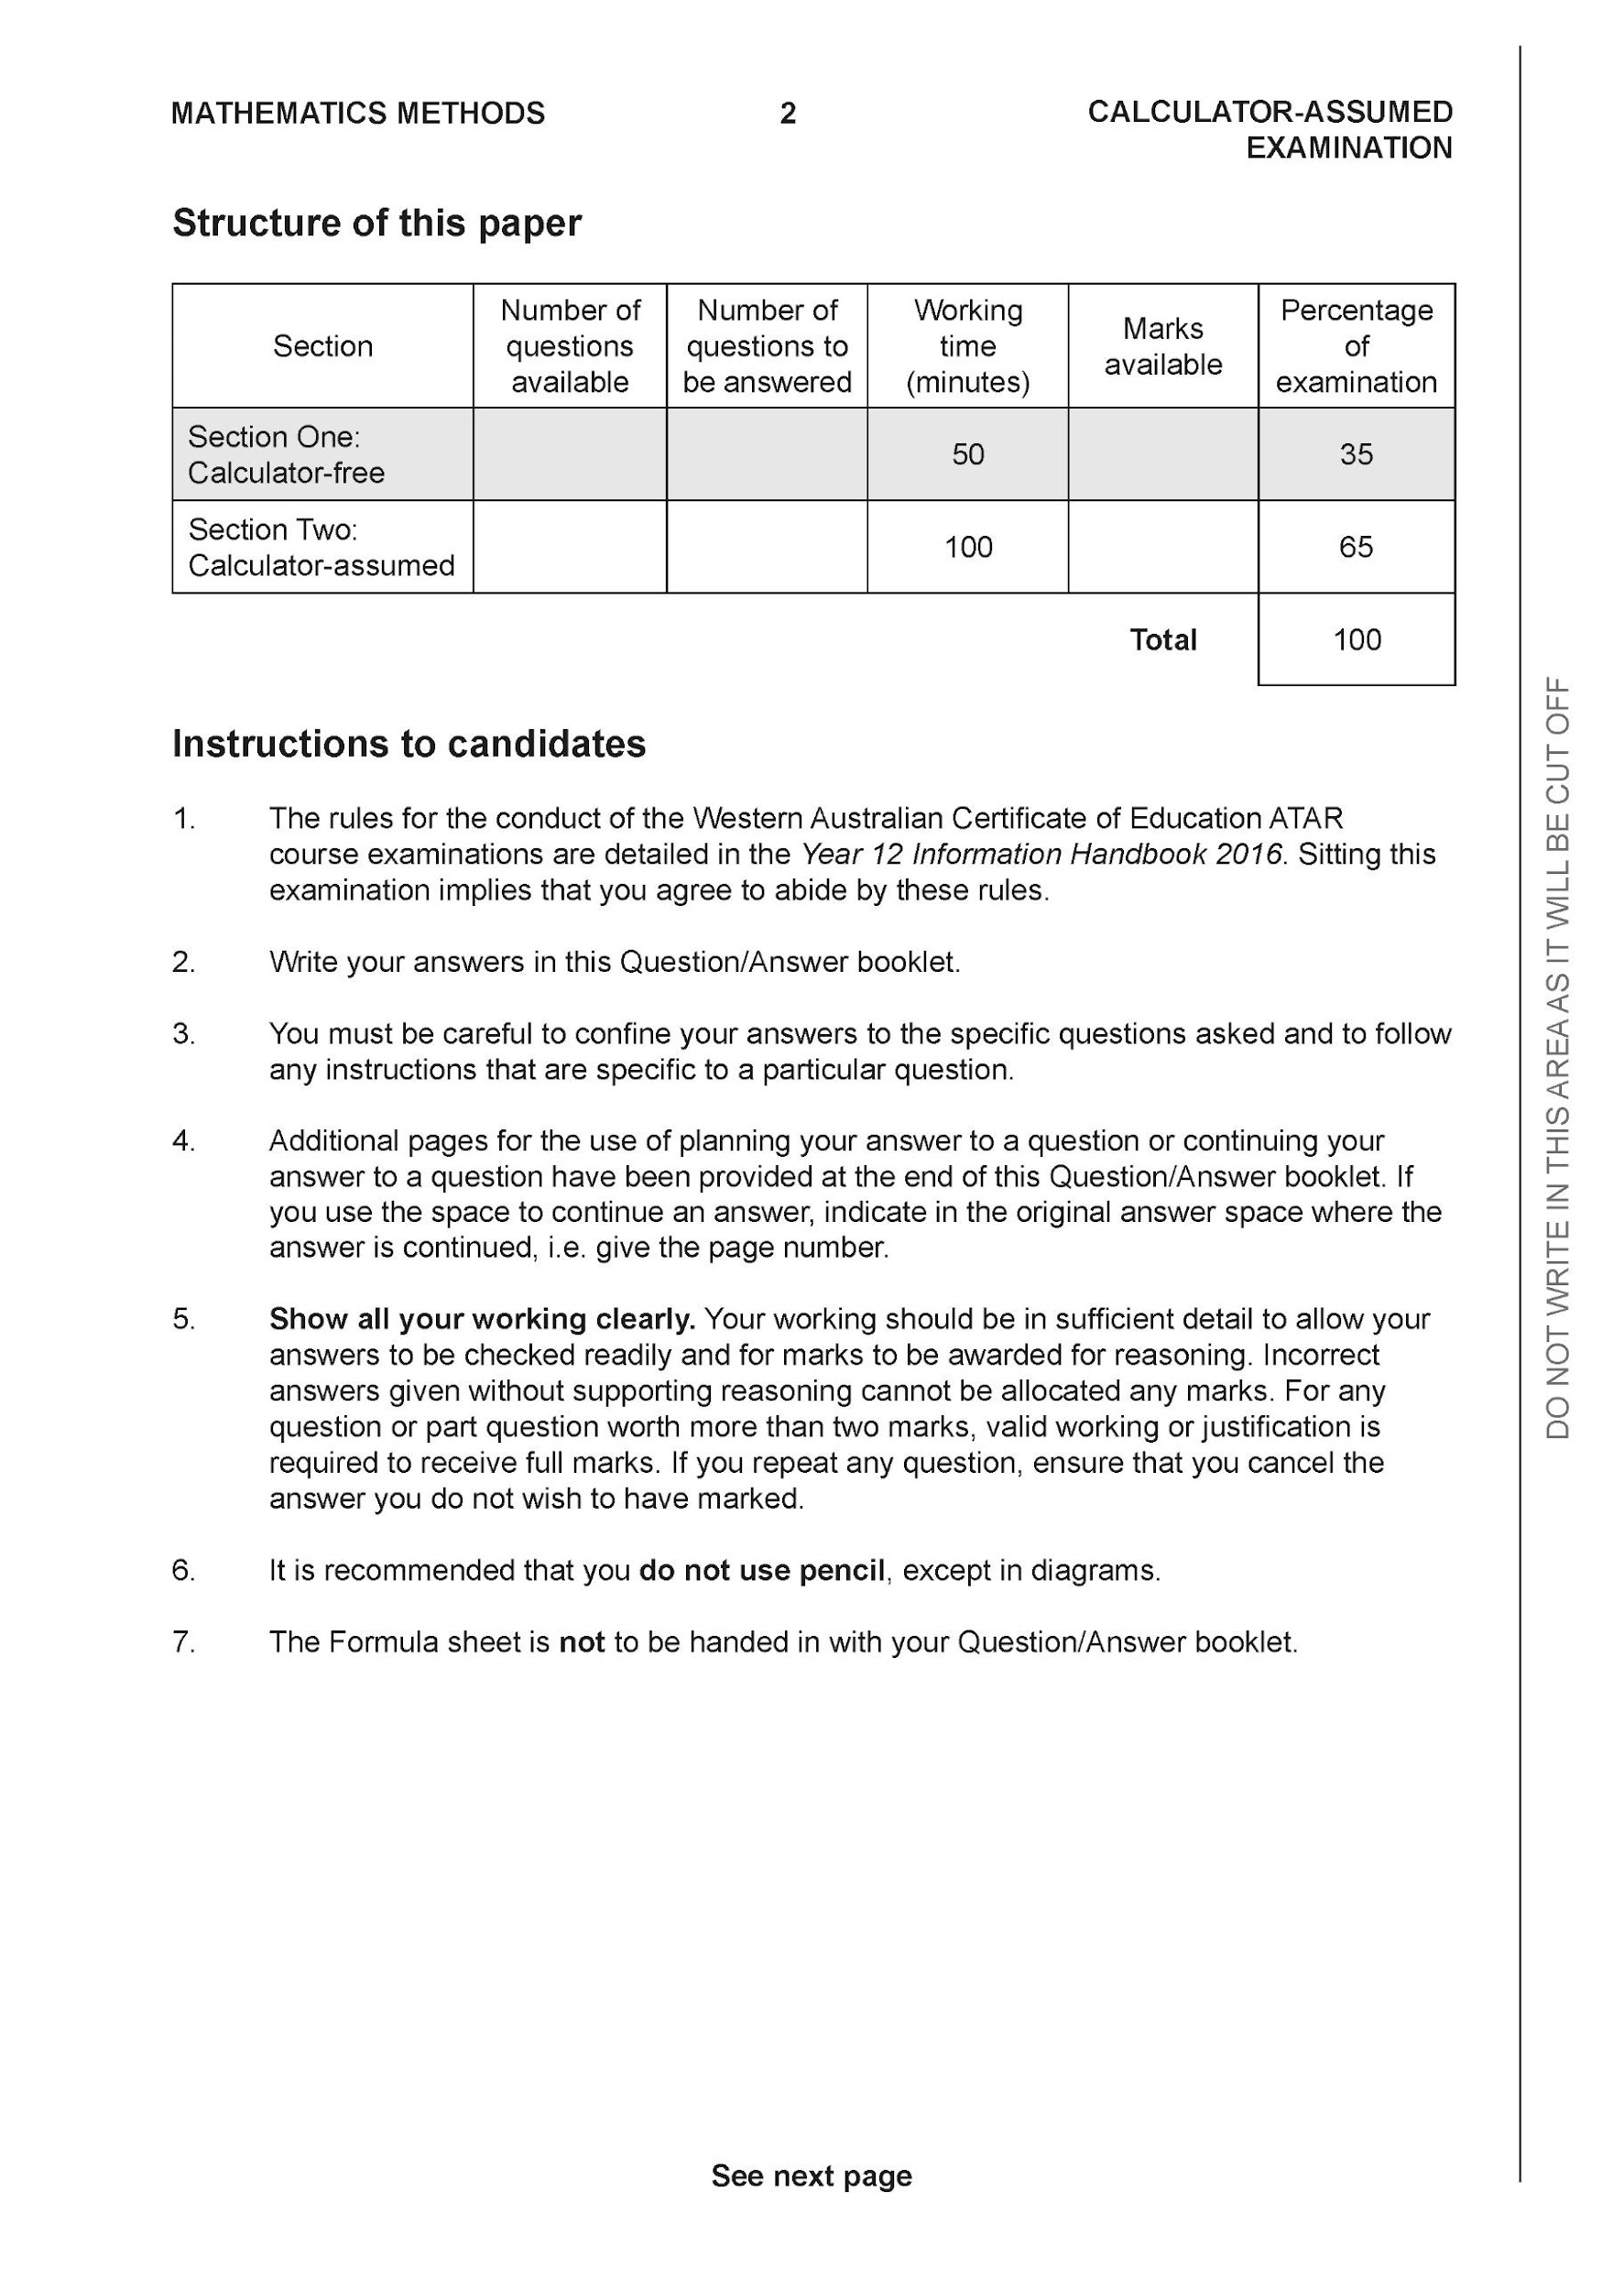

**Section Two: Calculator-assumed (85 Marks)**

This section has **14** questions. Answer **all** questions. Write your answers in the spaces provided.

Spare pages are included at the end of this booklet. They can be used for planning your responses and/or as additional space if required to continue an answer.

● Planning: If you use the spare pages for planning, indicate this clearly at the top of the page.

● Continuing an answer: If you need to use the space to continue an answer, indicate in the original answer space where the answer is continued, i.e. give the page number. Fill in the number of the question that you are continuing to answer at the top of the page.

Working time: 100 minutes.

**Question 10 {1.1.28} (4 marks)**

Apply the vertical line test to each of the following graphs and conclude whether the graph represents a relation or a function.

1. ____________FUNCTION **✓** b) RELATION  **✓**

1. ___ RELATION **✓** d) FUNCTION **✓**

**Question 11 (1.1.1 – 1.1.6) (2, 2, 1, 3, 2 = 10 marks)**

The kite ABCD is graphed below.

The coordinates of the vertices are A(2, 5), B(4, 6), C(5,4) and D(*x*, 0) as shown below.

NB Kites have diagonals that meet at right angles.

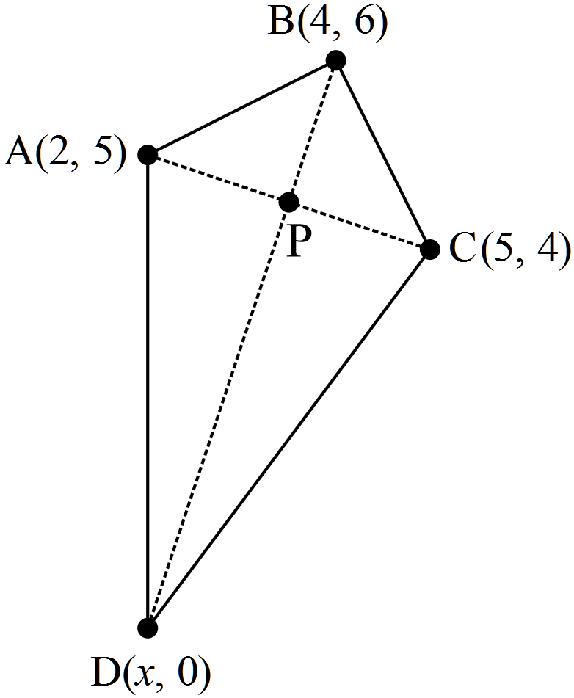

(a) Show that AB = BC.









(b) Find the gradient of AC and hence the equation of the diagonal BD.







(c) Determine the value of d, the x co-ordinate of point D.

**✓**



(d) Find the midpoint of AC and show it belongs to diagonal BD.

**✓**



**✓✓**



(e) Show how the midpoint of AC could have been used to determine the

value of







**Question 12 {1.1.26} (4 marks)**

1. Give the equation of the image after the following transformation:

Translate 3 units horizontally left followed by reflection in the -axis.

| **Solution** |
| --- |
|  |
| **Specific behaviours** |
| ✔+ 3  ✔Applies negative to the whole function |

1. Give the equation of the image after the following transformation:

Translate vertically up 2 units then reflect in the -axis.

| **Solution** |
| --- |
|  |
| **Specific behaviours** |
| ✔+ 2  ✔Applies negative to the only |

**Question 13 {2.3.4} (3 marks)**

Determine the gradient of the secant passing through the graph at the points where and .



**Question 14 {2.3.1} (3,2 = 5 marks)**

A car’s position at time seconds is represented by metres, where:

By first calculating the relevant positions of the car, determine its average velocity in:

1. the first 2 seconds.



No penalty for missing units.

1. the last 2 seconds.



**Question 15 {2.3.5, 2.3.8) (3, 1 = 4 marks)**

A balloon’s volume at time seconds is represented by , where:

1. Using the difference quotient, determine the average rate of change over .



1. Hence, determine the rate of change as .



**Question 16 {2.3.6} (4 marks)**

Differentiate by first principles.



**Question 17 {2.3.19} (3, 2, 3, 4 = 12 marks)**

A particles position (in metres) with respect to time (in seconds) is given by the following equation:

where

1. Given that the particle is initially at the origin and has a displacement of 27 metres at 3 seconds, determine the values of a & b.

|  |
| --- |
| **Specific behaviours** |
| Substitutes in t = 0 to find b  Substitutes in t = 3  Finds a |

1. Determine the particles position at 5 seconds to 2 decimal places.

| **Solution** |
| --- |
|  |
| **Specific behaviours** |
| Answer  2 d.p. |

1. Use calculus techniques to determine when the particle is at rest.

| **Solution** |
| --- |
|  |
| **Specific behaviours** |
| Differentiates  Equates to zero  Solves |

1. Use calculus techniques to determine the maximum displacement of the particle.

|  |
| --- |
| **Specific behaviours** |
| Determines nature of t.p at t=3 (sign test, double derivative test or checking function values either side acceptable) .  Determines nature of t.p at t=7 (sign test, double derivative test or checking function values either side acceptable) .  Solves for the displacement when t =3.  States maximum displacement and time.  Notes:  Minus one mark for not supplying values for tests and simply saying +’ve or –‘ve.  Not required to check boundary points of domain but should be mentioned after the examination that a local maximum isn’t necessarily a global maximum. |

**Question 18 {2.3.22} (3, 6 = 9 marks)**

Given that runs through the point (2,4) and :

1. Determine

| **Solution** |
| --- |
|  |
| **Specific behaviours** |
| Anti-differentiates  Substitutes in x=2 to find c  States f(x) |

1. Using calculus techniques find the location and nature of any stationary points.

| **Solution** |
| --- |
|  |
| **Specific behaviours** |
| Equates differential equation to zero  Solves correctly  Determines location of t.p. at x = -1  Determines location of t.p. at x = 1  Determines nature of t.p at x=1 (sign test or double derivative test).  Determines nature of t.p at x=-1 (sign test or double derivative test) .  Notes:  No mark for not supplying values for tests and simply saying +’ve or –‘ve. |

**Question 19 {2.3.22} (8 marks)**

Anika has her own private plane that she uses to travel from Perth to Melbourne.

The amount of fuel she consumes on the journey and therefore the cost of her flight, C ($), is dependent on the speed at which she flies, x (km/h).

The relationship between the overall cost of the flight is modelled by the equation below.

where

Use calculus techniques to determine both the **optimal speed** to travel in order to minimise the cost of her journey and the **cost of that flight**.

| **Solution** |
| --- |
|  |
| **Specific behaviours** |
| Differentiates  Equates differential equation to zero  Solves correctly  (2 marks) Performing sign test or double derivative test correctly.  Stating / confirming that it is a minimum  Determines cost at x = 800  Stating optimal speed and associated cost  Notes:  No mark for not supplying values for tests and simply saying +’ve or –‘ve. |

**Question 20 {1.2.6} (4 marks)**

The region ABC is a sector of a circle with radius 30cm, centred at C. The angle in the sector is *θ*. The arc DE lies on a circle also centred at C, as shown in the diagram.

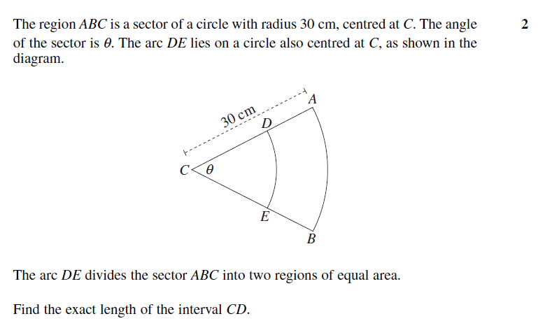

The arc DE divides the sector ABC into two regions of equal area.

Find the length of the interval CD.

| **Solution** |
| --- |
| (15  OR |
| **Specific behaviours** |
| ✔substitutes correctly for small sector  ✔substitutes correctly for large sector  ✔divides large sector by 2 |

**Question 21 {1.2.4} (4 marks)**

A ground search for a lost hiker is being organised using three camping sites in a national park as bases. It is known that the hiker is within the triangular area formed with the three campsites as vertices. Campsite A is 15km due east from campsite B. Campsite C is on a bearing of 170o from campsite A (hint : ). Campsite B is 20km from campsite C.



Note: The diagram is not to scale.

B 15 km A 



20 km

C

Calculate the area of the search to the nearest square kilometre.

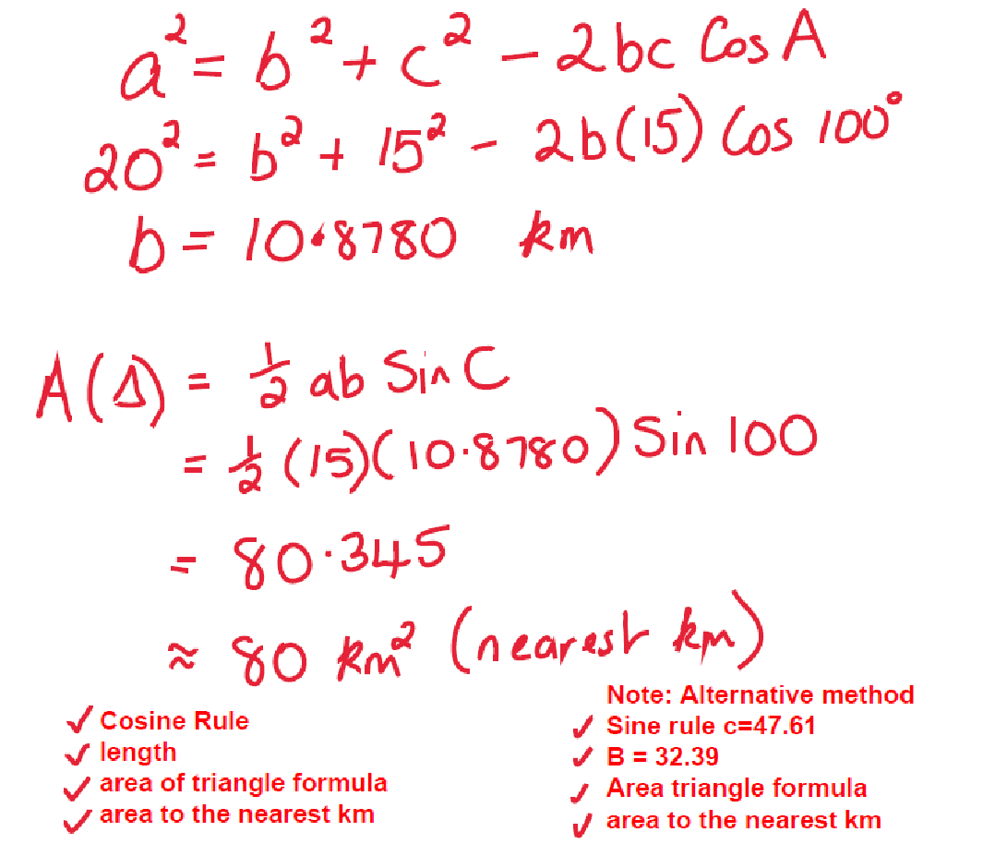

**Question 22 (1.3.11, 1.3.13) (2, 2, 2, 2 = 8 marks)**

There are 250 Year 11 students at Perth Modern School where 205 students study Chemistry.

1. Represent this information in a completed Venn diagram.

| Solution |
| --- |
|  |
| Specific Behaviours |
| ✔ Venn has a universe and 4 fields completed.  ✔ correct numbers. |

1. What is the probability that a student in Year 11 studies neither Mathematics Methods nor Chemistry?

| Solution |
| --- |
|  |
| Specific Behaviours |
| ✔ correct numerator  ✔ correct denominator |

1. Given that a student in Year 11 studies Mathematics Methods, what is the probability that they also study Chemistry?

| Solution |
| --- |
|  |
| Specific Behaviours |
| ✔ correct numerator  ✔ correct denominator |

1. Given that a student in Year 11 studies Chemistry, what is the probability that they also study Mathematics Methods?

| Solution |
| --- |
|  |
| Specific Behaviours |
| ✔ correct numerator  ✔ correct denominator |

**Question 23 (1.3.7, 1.3.11, 1.3.14, 1.3.16) (1, 1, 1, 1, 1, 1 = 6 marks)**

1. Events A and B are such that , and . Determine:

| Solution |
| --- |
|  |
| Specific Behaviours |
| ✔ correct answer |



| Solution |
| --- |
|  |
| Specific Behaviours |
| ✔ correct answer |

1. Given , and . Determine:

| Solution |
| --- |
|  |
| Specific Behaviours |
| ✔ correct answer |



| Solution |
| --- |
|  |
| Specific Behaviours |
| ✔ correct answer |



| Solution |
| --- |
|  |
| Specific Behaviours |
| ✔ correct answer |



| Solution |
| --- |
|  |
| Specific Behaviours |
| ✔ correct answer |

**END of SECTION**

**Additional working space**

Question number:

**Additional working space**

Question number:

**Additional working space**

Question number:

**Additional working space**

Question number: